Cervical Cancer Cell Classification on the SIPaKMeD Dataset: A Comparative Study of Ten Deep Learning Architectures with a Soft-Voting Top-3 Ensemble
Bhavana Poli, Dr. Tripty Singh
Department of Computer Science and Engineering, Amrita Vishwa Vidyapeetham, Bengaluru, India
Abstract
Cervical cancer is the fourth most common cancer in women worldwide and a decrease in the mortality rate will only be achieved if potentially malignant and precancerous cells can be detected from Papanicolaou (Pap) smear pap slides. This paper aims to provide a systematic and comparative analysis of ten deep-learning architectures for a 5-class cervical cell classification task on SIPaKMeD benchmark, including classical convolutional networks (VGG16, ResNet50, DenseNet121, Inception-V3), efficient architectures (EfficientNet-B3, MobileNetV3-Large), modern convolutional architectures (ConvNeXt-Tiny), transformer-based backbones (ViT-B/16, Swin-Tiny), and a custom from-scratch CNN baseline. They are all fine-tuned for 20 epochs using a common albumentations augmentation pipeline that contains CLAHE contrast enhancement, affine and photometric transformations, multi-source noise, blur and coarse dropout. We then create three soft voting ensemble compositions (Top-3, Top-5, All-10) by taking a uniform average of softmax probability vectors of the underlying models. The accuracy on 146 held-out images in the test set is 96.58%, with macro F1 score of 0.9702, macro AUC-ROC of 0.9982, and weighted F1 of 0.9660, which is superior to the best single model (ResNet50, 95.89%) and comparable to the larger Top-5 ensemble. The ensemble takes the perfect score of F1 = 1.0000 on the Parabasal class and F1 ≥ 0.97 on Superficial-Intermediate.

Keywords:
Medical image analysis; Deep learning ensemble; soft voting; ResNet50; DenseNet121; EfficientNet-B3; Pap smear classification; cervical cancer detection; SIPaKMeD.

1. Introduction
In the developing world, and especially in low- and middle-income countries, trained pathologists and sophisticated diagnostic facilities are scarce, making cervical cancer a major contributor to cancer-related deaths among women [1]. Since its inception, the Papanicolaou (Pap) test has been the cornerstone of cervical cancer screening, allowing for the detection of abnormal cell morphology that may indicate dysplasia or malignancy. Manual reading of Pap smears is, however, labour-intensive, time consuming and requires inter-observer variability [2].
Medical picture classification has shown outstanding performance in the field of deep learning image analysis automated systems. Another approach which has gained popularity in recent years is to directly learn hierarchical representations from raw pixel values, as is the case for the convolutional neural networks (CNNs) and Vision Transformers (ViTs) which beat traditional pipeline solutions on difficult benchmarks and sometimes match them in performance [3].
The five class classification task is defined as follows. Suppose that the space of input images is 𝒳 ⊂ ℝ^(H×W×3), and the discrete label space is 𝒴 = {1, 2, …, C} with C = 5 classes. The objective is to learn a mapping
fθ : 𝓟_train → Δ^(C−1) on a training set of N labelled samples 𝓟_train = {(xᵢ, yᵢ)}ᵢ₌₁ⁿ, with the probability simplex over class labels Δ^(C−1) and the recovered class ŷ(x) = argmax_c fθ(x)_c.
The SIPaKMeD dataset [4] is an isolated cervical cell dataset publicly available, consisting of single-cell images across 5 clinically meaningful classes: Dyskeratotic (abnormal), Koilocytotic (abnormal), Metaplastic (benign), Parabasal (normal), and Superficial-Intermediate (normal). Examples of images for every class are presented in Figure 1.
The representative types of cervical cell classes shown in Figure 1 are: (a) Dyskeratotic Class (b) Koilocytotic Class (c) Metaplastic Class (d) Parabasal Class (e) Superficial-Intermediate Class. The two abnormal classes (a, b) are morphologically similar, and this is the major cause of classification errors that are reported in Section 5.

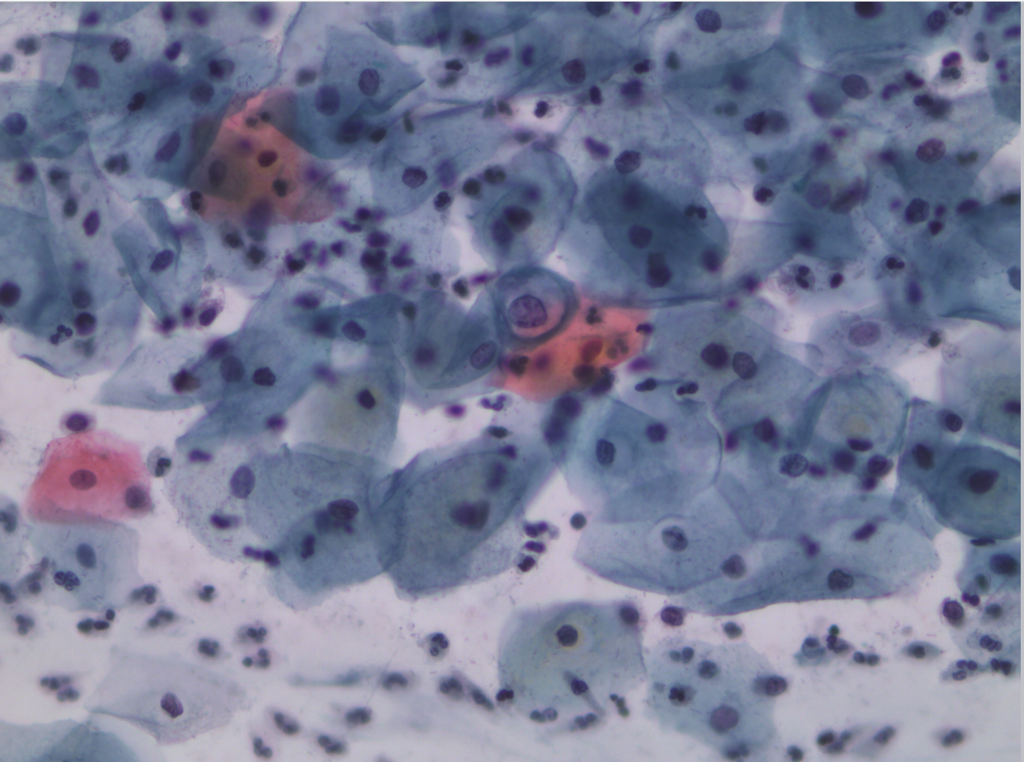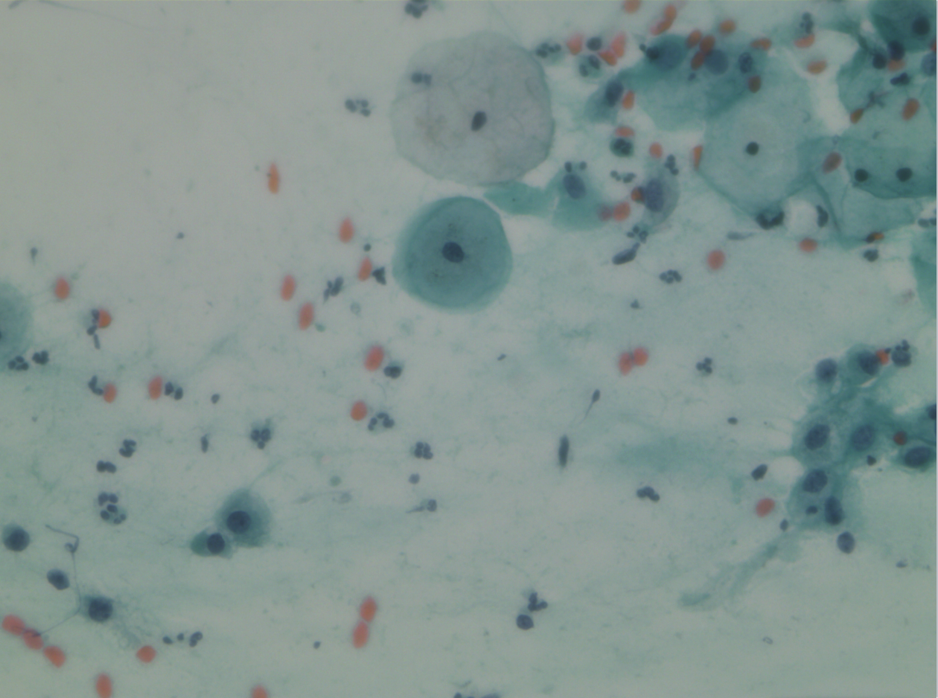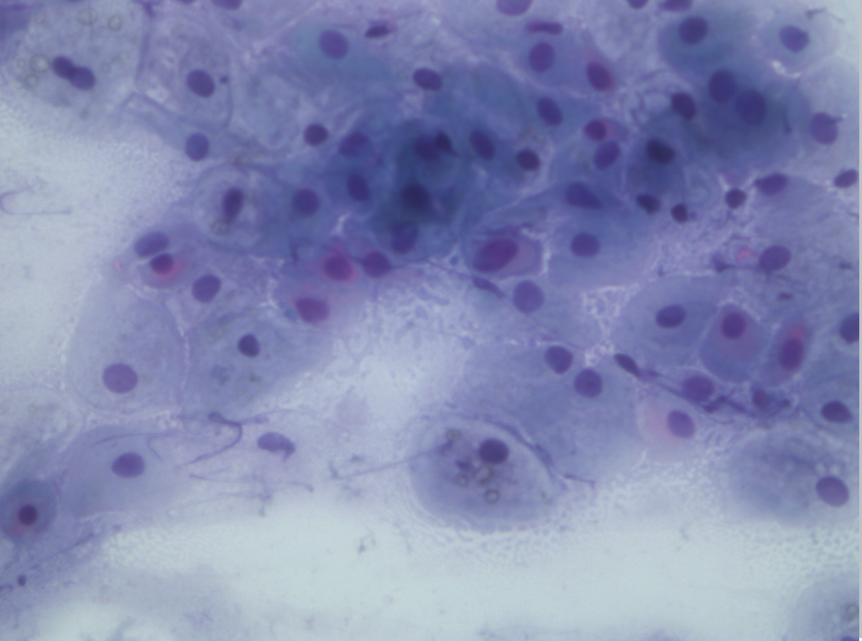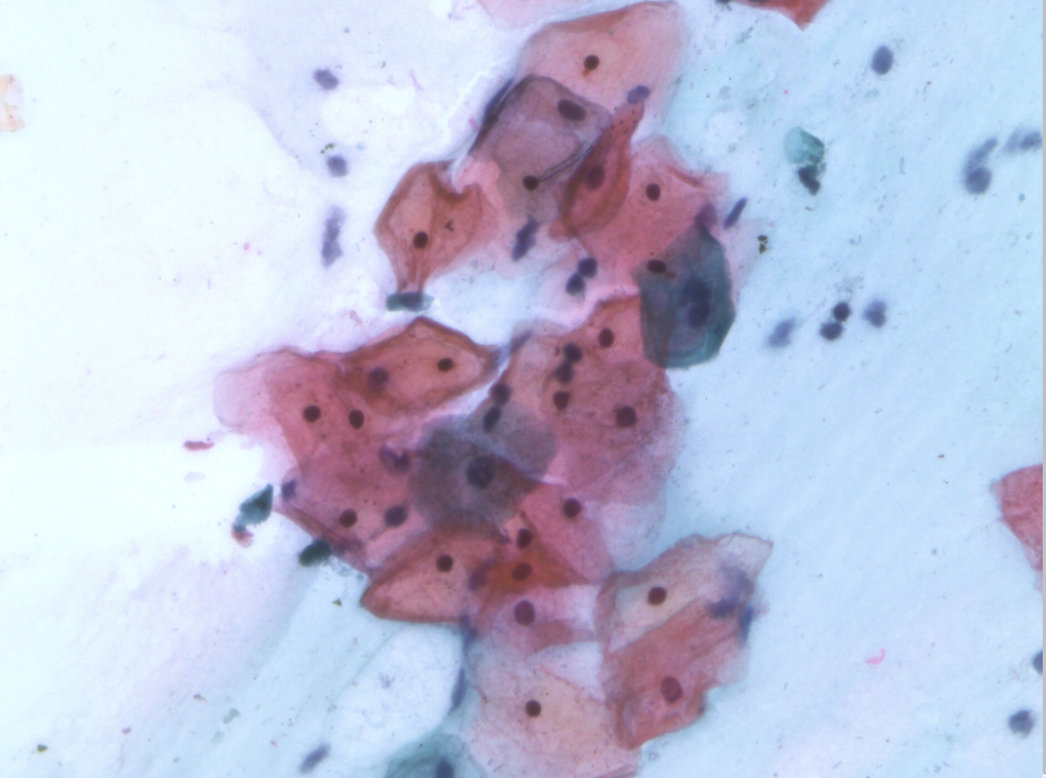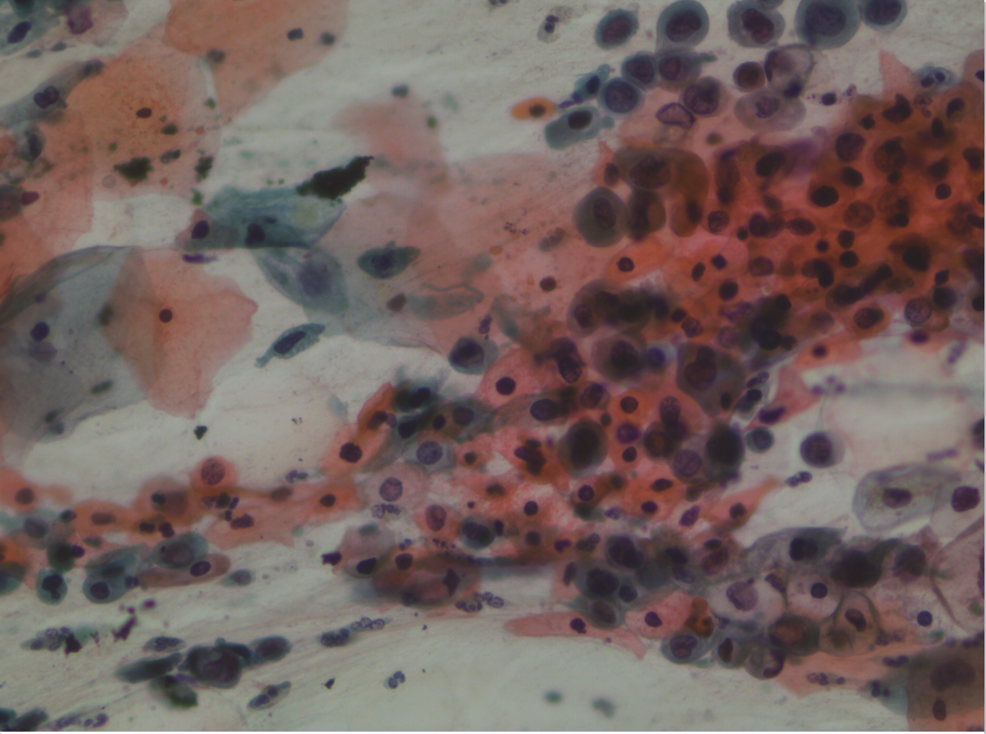
Figure1:Different classes of cervical cells are represented , metaplastic, parabasal, superficial-intermediate, dyskeratotic, and koilocytotic cells. Note that the two classes (a, b) are morphologically similar and this is the main reason for reporting classification error when a score is given in Section 5.

In this paper, we provide a uniform-protocol benchmark of 10 deep learning architectures for SIPaKMeD followed by the design of three soft-voting ensemble compositions and analysis. In this paper, we will introduce a uniform-protocol benchmark with the same training condition, and we will evaluate 10 different architectural families and compare the three different ensemble compositions (Top-3, Top-5, All-10) which are composed of these models.

This paper's primary contributions are:
- For 10 different architectures (custom CNN, VGG16, ResNet50, DenseNet121, Inception-V3, MobileNetV3-Large, EfficientNet-B3, ConvNeXt-Tiny, ViT-B/16, Swin-Tiny), evaluate accuracy, macro F1, macro AUC, number of parameters, and inference latency, with identical training parameters.
- Three different soft voting ensemble compositions (Top-3, Top-5, All-10), which showed that the Top-3 combination of ResNet50, DenseNet121 and EfficientNet-B3 is the strongest performer under the evaluated experimental setting with 96.58% accuracy and 0.9702 macro F1, and the All-10 ensemble with a weak baseline does not improve upon the best single model.
- A breakdown by class showing that the Parabasal class was perfectly classified (F1 = 1.0000), while the Dyskeratotic-Koilocytotic abnormal-class pair contained the rest of the error rates; this is a relatively lower risk error pattern since the errors are still grouped within the morphologically similar abnormal classes.
- A comparison of accuracy vs. computational cost for all 10 architectures.

2. Related Work
Previous automatic classification systems used hand-crafted features for cervical cell classification. Plissiti et al. [7] created the dataset SIPaKMeD and an SVM classifier with HOG features yielding 84.12% accuracy. This provided a good starting point but was based on manual feature engineering and thus was only applicable to unseen morphological variations. In the medical image classification domain, modern performance has been achieved using CNNs specially optimized for medical image classification [9] in various medical pathology domains.
To further enhance the discrimination, attention mechanisms and multi-scale feature fusion are explored. Multi-resolution approaches based on DWT have demonstrated to be effective in medical image fusion for obtaining complementary information from different imaging modalities [10].
But ensemble methods have been a common approach since the 1990s. For medical imaging applications, the improvement of the prediction confidence by means of soft voting (averaging predictions over models) and multi-layer, multi-modal medical image intelligent fusion [12] has been extensively used.
Performance was greatly boosted by transferring the weights of the architectures pre-trained on ImageNet. Taha et al. [8] used VGG16 and fine-tuned on SIPaKMeD; the accuracy obtained was 91.34%. The following steps further tuned the deeper backbones and reported single model accuracy in the range of 94-95%. There have also been lightweight architectures like MobileNet, and EfficientNet which are compromising on just a little accuracy but offer significantly reduced model sizes.
Further effort has been made to boost discrimination using attention mechanisms and multi-scale feature fusion. Kuko and Pudil [11] combined spatial attention and a customized CNN to achieve a 93.78% accuracy. Transformer-based methods are more recently explored for cell-classification tasks. However, to the best of our knowledge, this research is the first to rigorously analyse numerous compositions of ensembles of these architectures for the SIPaKMeD and compare ten families of the architectures in a standard protocol. Since the 1990s, ensemble methods have been a widely used approach [23]. One of the simplest ensemble techniques is soft voting, which is an averaging of the predicted probability distributions, with no need for additional training, no changes to the architecture and yields a valid probability distribution that can be used for confidence-based downstream decisions. Although it is a simple approach, soft voting has not been systematically compared to a single model on the cervical cytology dataset. To fill that void, this work investigates soft voting under three different ensemble compositions and the same underlying ten architectures.

3.DATASET

3.1 SIPaKMeD Dataset
SIPaKMeD dataset [4] comprises single cell images obtained from the cluster-cell images of Pap smear slides. The data set used for this study is a set of 966 cell images for five classes as listed in Table 1.

Table 1: Class distribution in the SIPaKMeD dataset which is used in this study.

Class | # Images | Category
Dyskeratotic | 223 | Abnormal
Koilocytotic | 238 | Abnormal
Metaplastic | 271 | Benign
Parabasal | 108 | Normal
Superficial-Intermediate | 126 | Normal
Total | 966 | —

3.2 Data Split
The entire dataset 𝓟 is divided into three disjoint subsets, with the same fixed random seed (seed = 42). With |𝓟| = 966, the split sizes are |𝓟_train| = 676, |𝓟_val| = 144, and |𝓟_test| = 146 (approximately 70/15/15). Across the 10 models the split is kept fixed, so that it is a proper comparison; the proportions of the classes in all 3 subsets are roughly preserved.

4. Methodology
Having the dataset and the preprocessing pipeline in place, we now describe the 10 architectures to compare and the uniform training protocol used. The entire pipeline, ranging from the ingestion of data to the soft voting ensemble inference and evaluation, is shown in Figure 2.
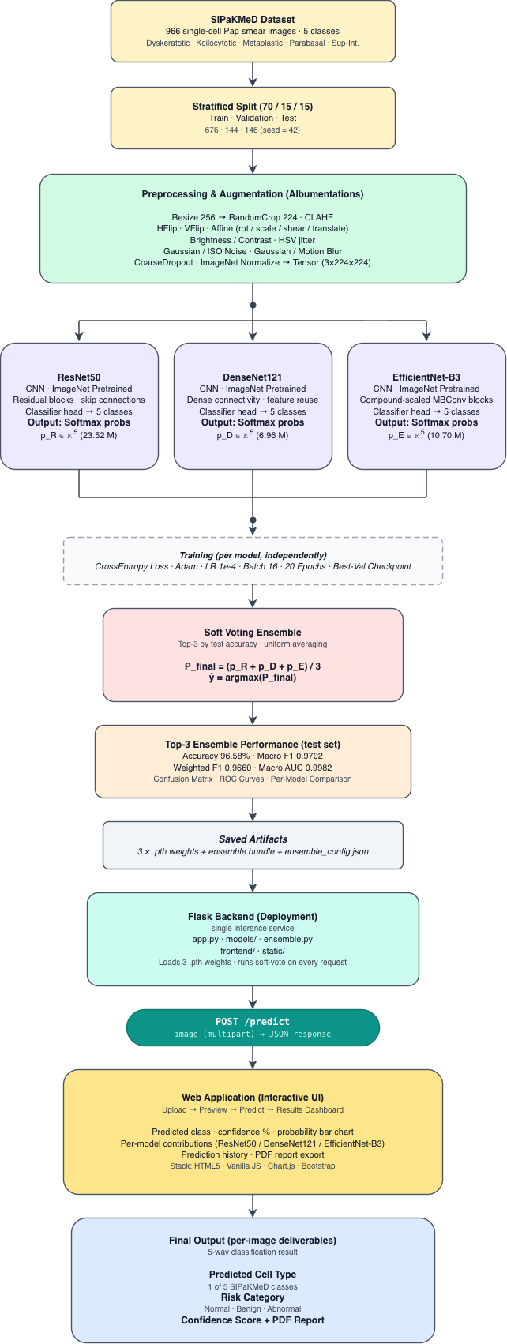
Figure 2:Proposed soft voting ensemble pipeline. All of the SIPaKMeD images go through a common Albumentations augmentation pipeline (resize, CLAHE, geometric transforms, noise, blur, coarse dropout), and are then processed in parallel by three independently fine-tuned CNN backbones (ResNet50, DenseNet121 and EfficientNet-B3). Every network generates a probability vector P_i ∈ Δ⁴ of dimension of 5. The average of the three vectors is computed uniformly (Eq. 2) and the argmax of the average distribution provides the final prediction class with a confidence score.

4.1 Image Pre-processing and Augmentation
Each input image is resized to 224×224 (299×299 for Inception-V3) and channel wise normalized using ImageNet statistics: μ = (0.485, 0.456, 0.406), σ = (0.229, 0.224, 0.225). The training-time augmentation pipeline is the same for all 10 models and consists of: contrast-limited adaptive histogram equalization (CLAHE) with clip limit β = 4.0 and tile grid (8×8), horizontal and vertical flipping, affine transformation (rotation ±30°, scaling 0.85-1.15, translation ±10, and shear ±10), brightness/contrast jitter (±30), HSV jitter, randomly selected Gaussian noise or ISO noise (0.0001-0.001), randomly .selected Gaussian noise or motion blur (0.0001-0.001), and coarse (1-6) dropout of random rectangular patches of size 8-16 pixels. Only resize and normalization are applied to validation and test inputs. CLAHE is especially popular in the field of cytology to enhance local contrast of cell boundaries and nuclear details in images.

4.2 Model Architectures
Ten architectures across the most popular families of deep-learning vision models are benchmarked. There are nine models fine-tuned from pre-trained ImageNet weights and one is a custom CNN trained from scratch as a baseline. Each model is shown in Table 2.

Table 2: Architecture benchmarked in this study. The Top-3 ensemble was the three rows highlighted in bold.

Model | Family | Params (M) | Input size | Pretrained
Custom CNN (baseline) | From-scratch CNN | 4.72 | 224 | —
VGG16 | Classical CNN | 134.28 | 224 | ImageNet
ResNet50 | Residual CNN | 23.52 | 224 | ImageNet
DenseNet121 | Dense CNN | 6.96 | 224 | ImageNet
Inception-V3 | Multi-branch CNN | 24.36 | 299 | ImageNet
MobileNetV3-Large | Mobile-efficient | 4.21 | 224 | ImageNet
EfficientNet-B3 | Compound-scaled | 10.70 | 224 | ImageNet
ConvNeXt-Tiny | Modern CNN | 27.82 | 224 | ImageNet
ViT-B/16 | Vision Transformer | 85.80 | 224 | ImageNet
Swin-Tiny | Hierarchical Transformer | 27.52 | 224 | ImageNet

We have adopted the sequential 3×3 convolutions used in VGG16 [24] as a baseline backbone for medical image analysis. ResNet50 [25] incorporates residual skip connections to enable the training of deep networks with the problem of vanishing gradients. DenseNet121 [26] augments the dense blocks to reuse the features by connecting every layer to every next one. Inception-V3 [27] involves multi-branch modules and input of 299x299, which are factorized. ConvNeXt-Tiny [21] is an updated CNN architecture that pays tribute to some of the innovations from the transformer era, but maintains a fully convolutional network structure. The MobileNetV3-Large model [14] is optimized for low-latency inference with depthwise-separable convolutions, squeeze-and-excitation channel attention, and the hard-swish nonlinearity. The efficientNet-B3 [13] introduces the concept of mobile inverted bottleneck (MBConv) blocks and compound scaling with respect to depth, width and input resolution. In ViT-B/16 [15], the input is divided into 196 patch tokens, which are 16×16 patches, and a learnable [CLS] token is added before the sequence is fed into 12 transformer encoder blocks where the classification head reads the final [CLS] token. Swin-Tiny [22] is a hierarchical transformer model that can calculate self-attention in a shifted window of local representations. We use a linear layer with C = 5 logits and softmax for each pretrained backbone, replacing the original 1000-way ImageNet classifier.

4.3 Training Objective
We train each model separately by minimizing the categorical cross-entropy loss on the training set. The loss for a single sample (x, y) and predicted distribution p = fθ(x) is
ℒ_CE(p, y) = − log p_y (1)
The Adam optimizer [17] is used to update the parameters, with the following learning rate η= 1×10⁻⁴, the default momentum coefficient β₁ = 0.9, β₂ = 0.999, and ε= 10⁻⁸. For each model, they are trained for 20 epochs using mini-batches of size 16, and store the checkpoint with the highest validation accuracy seen during training for test-time use with best_validation_checkpointing. Inception-V3, we stick to the standard practice and add an auxiliary classifier loss with weight 0.4 to stabilize training.

4.4 Soft-Voting Ensemble
Assume the three fine-tuned models of the Top-3 ensemble, namely ResNet50, DenseNet121, and EfficientNet-B3, have three softmax probability vectors P_R(x), P_D(x), and P_E(x) respectively, for an input image x. We perform soft voting by taking the uniform average of the three probability vectors:
P_ens(x) = ( P_R(x) + P_D(x) + P_E(x) ) / 3 (2)
Alternatively, for any general ensemble ℳ of |ℳ| trained models, the ensemble probability is simply the average of the model probabilities, P_ens(x) = (1/|ℳ|) · Σ_{m∈ℳ} P_m(x). This uniform-averaging principle is followed for the Top-5 and the All-10 compositions as reported under Section 5. The final predicted class is retrieved by applying argmax to the distribution of classes averaged over the individual samples:
ŷ_ens(x) = argmax_(c ∈ {1,…,5}) P_ens(x)_c (3)
Summing the individual softmax outputs P_ens,c gives an average P_ens that is still a valid probability distribution (Σ_c P_ens,c = 1), allowing for the use of confidence-based downstream decision rules. The ensemble contains no trainable parameters and is an ad hoc mixture of 3 models that are trained independently of each other.

4.5 Evaluation Metrics
We report standard multi-class classification metrics. Let TP_c, FP_c, and FN_c be the number of true positive, false positive, and false negative results respectively in class c. Precision_c = TP_c / (TP_c + FP_c), Recall_c = TP_c / (TP_c + FN_c), and the per-class F1-score is:
F_(1,c) = 2 · Precision_c · Recall_c / (Precision_c + Recall_c) (4)
The macro F1 is the average of all F_(1,c) classes with equal weights, the weighted F1 is the average with weights proportional to class support n_c. The overall accuracy is the ratio of the number of samples for which ŷ_i = y_i to the total number of samples. The macro AUC-ROC is calculated by averaging the AUC-ROCs per class according to the one-versus-rest configuration.

5. Experiments and Results
We now report and analyse the empirical results on the held out test set, after specifying the training and ensemble protocols. All experiments were conducted on NVIDIA Tesla T4 (GPU 16 G) in the Kaggle cloud platform with PyTorch and TIMM. This total training time for all 10 models was about eight hours.

5.1 Per-Model Performance
The from-scratch custom CNN achieves significantly poorer performance (76.71%) than all pretrained CNNs, highlighting the benefits of ImageNet pretraining on this small medical dataset. Even though it is a relatively old model, the best performance is given by ResNet50 with a score of 95.89%. We find that transformer based backbones (ViT-B/16 and Swin-Tiny) with similar parameter counts as the smaller CNNs underperform in our setting, and a similar trend has been observed in the literature: transformers do not seem to be as powerful as CNNs of comparable size in the regime of limited data, lacking the convolutional inductive bias. MobileNetV3-Large has a 91.78% accuracy and only 4.21 M parameters, as well as a speed of inference of 1.42 ms/image.

Table 3: Per-model performance (n = 146) on the SIPaKMeD test set. The Top 3 ensemble is highlighted in bold text.
Model | Params (M) | Inf. (ms) | Val Acc | Test Acc | F1 Macro | F1 Wgt | AUC Macro
ResNet50 | 23.52 | 2.99 | 0.9444 | 0.9589 | 0.9647 | 0.9592 | 0.9958
DenseNet121 | 6.96 | 3.74 | 0.9444 | 0.9521 | 0.9589 | 0.9517 | 0.9982
VGG16 | 134.28 | 5.36 | 0.9375 | 0.9384 | 0.9496 | 0.9376 | 0.9953
ConvNeXt-Tiny | 27.82 | 4.26 | 0.9653 | 0.9384 | 0.9480 | 0.9378 | 0.9942
EfficientNet-B3 | 10.70 | 3.46 | 0.9444 | 0.9247 | 0.9317 | 0.9242 | 0.9951
MobileNetV3-Large | 4.21 | 1.42 | 0.9375 | 0.9178 | 0.9315 | 0.9180 | 0.9962
Inception-V3 | 24.36 | 4.18 | 0.9444 | 0.9178 | 0.9303 | 0.9182 | 0.9963
Swin-Tiny | 27.52 | 4.51 | 0.9514 | 0.9110 | 0.9209 | 0.9088 | 0.9929
ViT-B/16 | 85.80 | 12.76 | 0.9444 | 0.9041 | 0.9163 | 0.9026 | 0.9923
Custom CNN | 4.72 | 1.94 | 0.7708 | 0.7671 | 0.7628 | 0.7674 | 0.9523

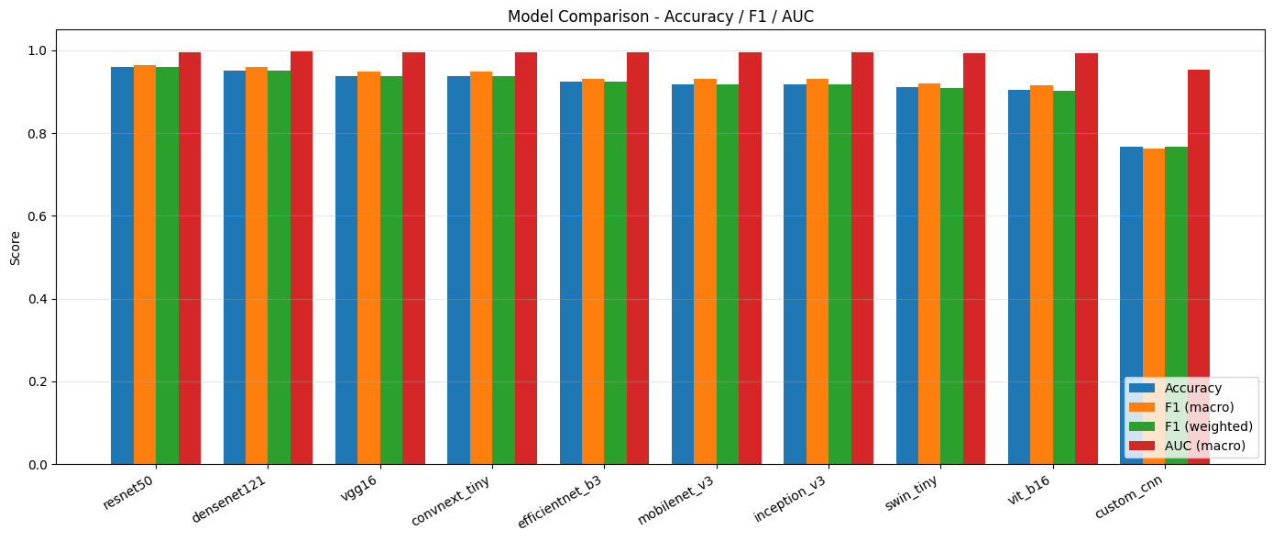

Figure 3: Benchmark results of the 10 architectures. The test accuracy and macro F1 values for each architecture are represented by bars on the SIPaKMeD test set. The three highest ranking ensemble members (ResNet50, DenseNet121, EfficientNet-B3) are shaded in a darker color.

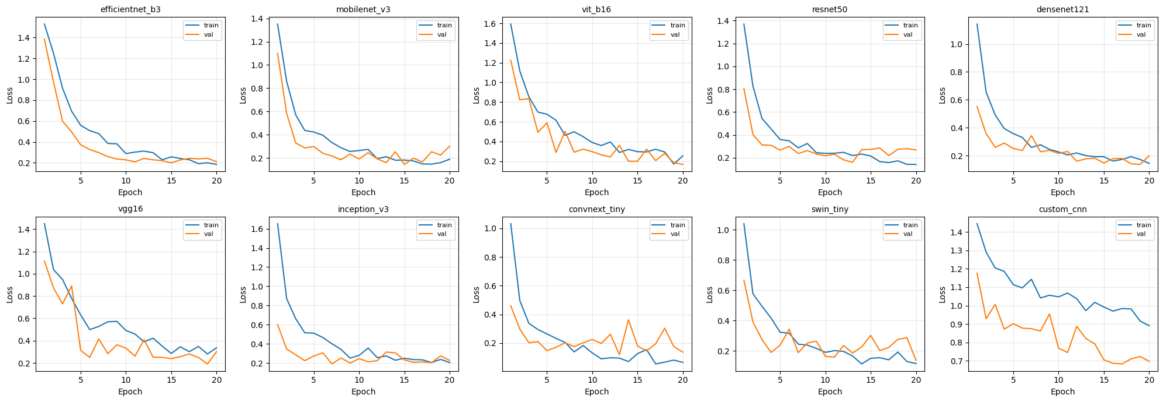
Figure 3. Ten architectures are evaluated on the SIPaKMeD dataset and their training and validation loss curves are shown over 20 epochs. The majority of pretrained models exhibit stable convergence as the loss decreases and a small train–validation gap (controlled overfitting), showing good transfer learning performance. The custom CNN, on the other hand, shows a slower convergence and higher residual loss.

5.2 Ensemble Performance
There are three ensemble compositions evaluated, reported in Table 4. The Top-3 ensemble (ResNet50 + DenseNet121 + EfficientNet-B3) and the Top-5 ensemble (the same three + ConvNeXt-Tiny + VGG16) both get 96.58% test accuracy, but the Top-3 requires less number of models and forward passes. The weak custom-CNN baseline is included in the ensemble and does not help it perform better than the best individual model: the weak member's noisy probability vector weakens the ensemble signal.
Table 4: Comparison of three ensemble compositions and the best single model on the held out test set (n = 146).

Ensemble | Members | Test Acc | F1 Macro | F1 Wgt | AUC Macro | Δ vs best single
Top-3 (R + D + Eff) | 3 | 0.9658 | 0.9702 | 0.9660 | 0.9982 | +0.0069
Top-5 | 5 | 0.9658 | 0.9723 | 0.9663 | 0.9992 | +0.0069
All-10 | 10 | 0.9589 | 0.9646 | 0.9588 | 0.9988 | +0.0000
Best single (ResNet50) | 1 | 0.9589 | 0.9647 | 0.9592 | 0.9958 | —

The Top-3 ensemble improves accuracy over the best single model (ResNet50, 0.9589) by 0.69 percentage points, macro F1 from 0.9647 to 0.9702, and macro AUC-ROC from 0.9958 to 0.9982. The AUC is just under 1 even though it is relatively low, meaning that the model has a very high level of ability to discriminate between the classes.
5.3 Per-Class Performance
The per-class precision, recall and F1-scores of the Top-3 ensemble are shown in Table 5. For the Parabasal class, Precision = Recall = F₁ = 1.0000 (perfect classification), and for the Superficial-Intermediate class, F₁ > 0.97. The most difficult class to classify is Dyskeratotic (F₁ = 0.9444) and the most frequent misclassification among the predictions of the ensemble is between Dyskeratotic and Koilocytotic, both of which have abnormalities in the nuclei. Importantly, both are abnormal classes that would be treated with the same classification triage and this residual confusion does not cause false reassurance to the patient.

Table 5: The per class precision, recall and F1 score for the Top-3 soft voting ensemble on the SIPaKMeD test set.

Class | Precision | Recall | F1-score | Support
Dyskeratotic | 0.8947 | 1.0000 | 0.9444 | 34
Koilocytotic | 1.0000 | 0.9189 | 0.9577 | 37
Metaplastic | 1.0000 | 0.9459 | 0.9722 | 37
Parabasal | 1.0000 | 1.0000 | 1.0000 | 17
Superficial-Intermediate | 0.9545 | 1.0000 | 0.9767 | 21
Macro Avg | 0.9699 | 0.9730 | 0.9702 | 146
Weighted Avg | 0.9689 | 0.9658 | 0.9660 | 146

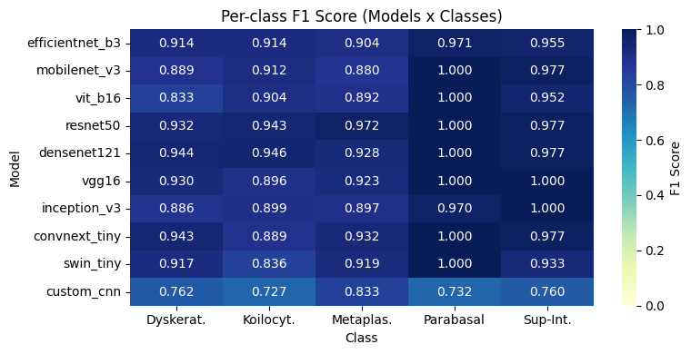
Figure 4:Per-Class Classification Performance of the 10 Deep Learning Architectures on SIPaKMeD (F1-Score Heatmap)
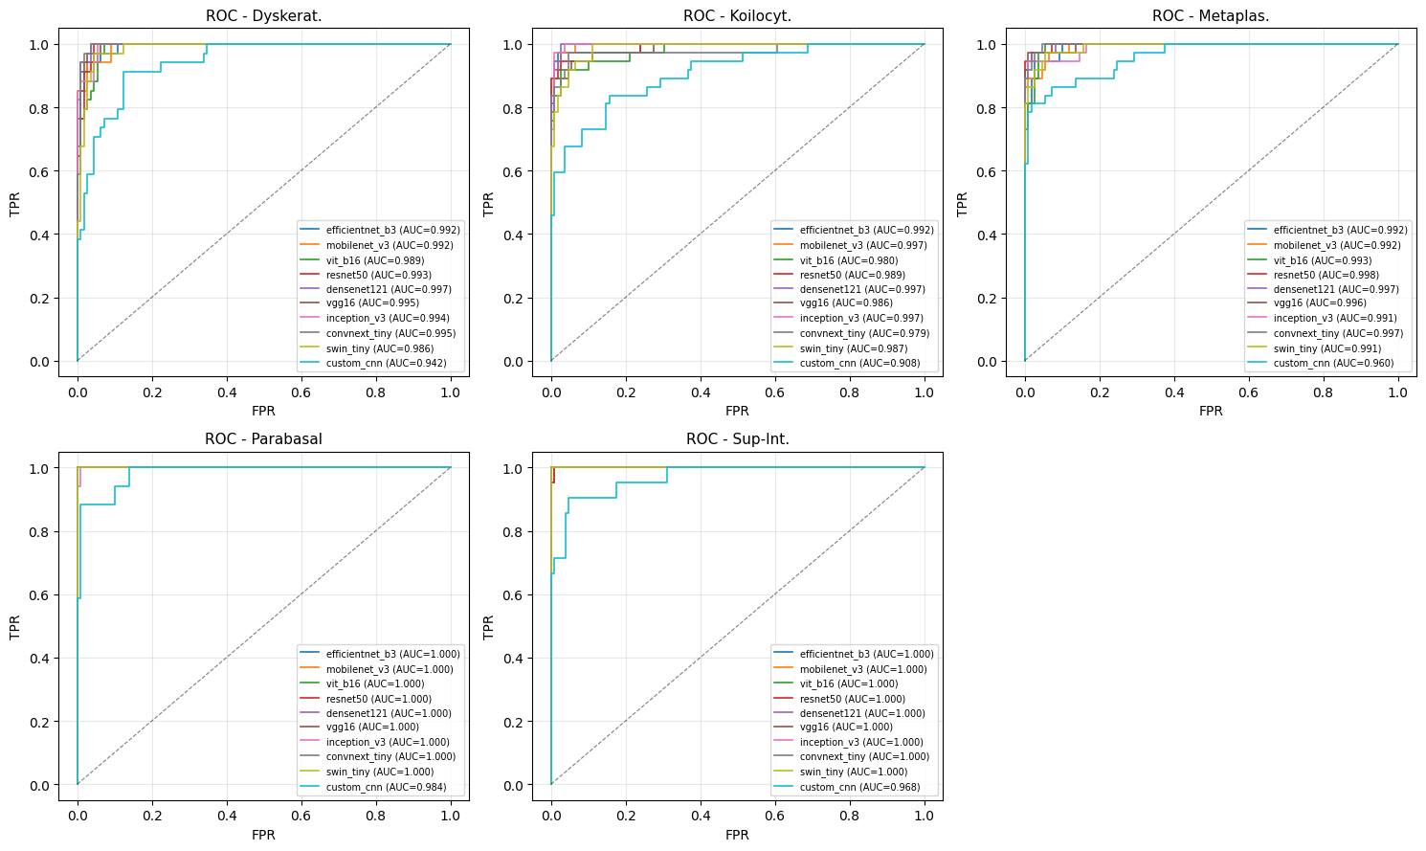
Figure 5: One-vs-Rest ROC Curves for the five different classes of cervical cells used for evaluation on the evaluated architectures.The per-class discrimination performance (AUC-ROC) is presented in each subplot. Nearly all of the pretrained architectures have an AUC above 0.99 for the perfect discrimination: the custom CNN has comparatively weak separability. The proposed Top-3 soft voting ensemble is supported by the strong ROC performance, which led to the selection of ResNet50, DenseNet121, and EfficientNet-B3.

5.4 Confusion Matrix and Discrimination
The confusion matrix of the Top-3 ensemble is shown in Figure 5. The results of the per-class analysis above are confirmed by the matrix: Classification is almost perfect for classes Parabasal and Superficial-Intermediate, and there are a few confusions in the three classes, which are morphologically closely related, Dyskeratotic, Koilocytotic and Metaplastic. Strong per-class discrimination is seen in the macro AUC-ROC, which resulted in 0.9982.
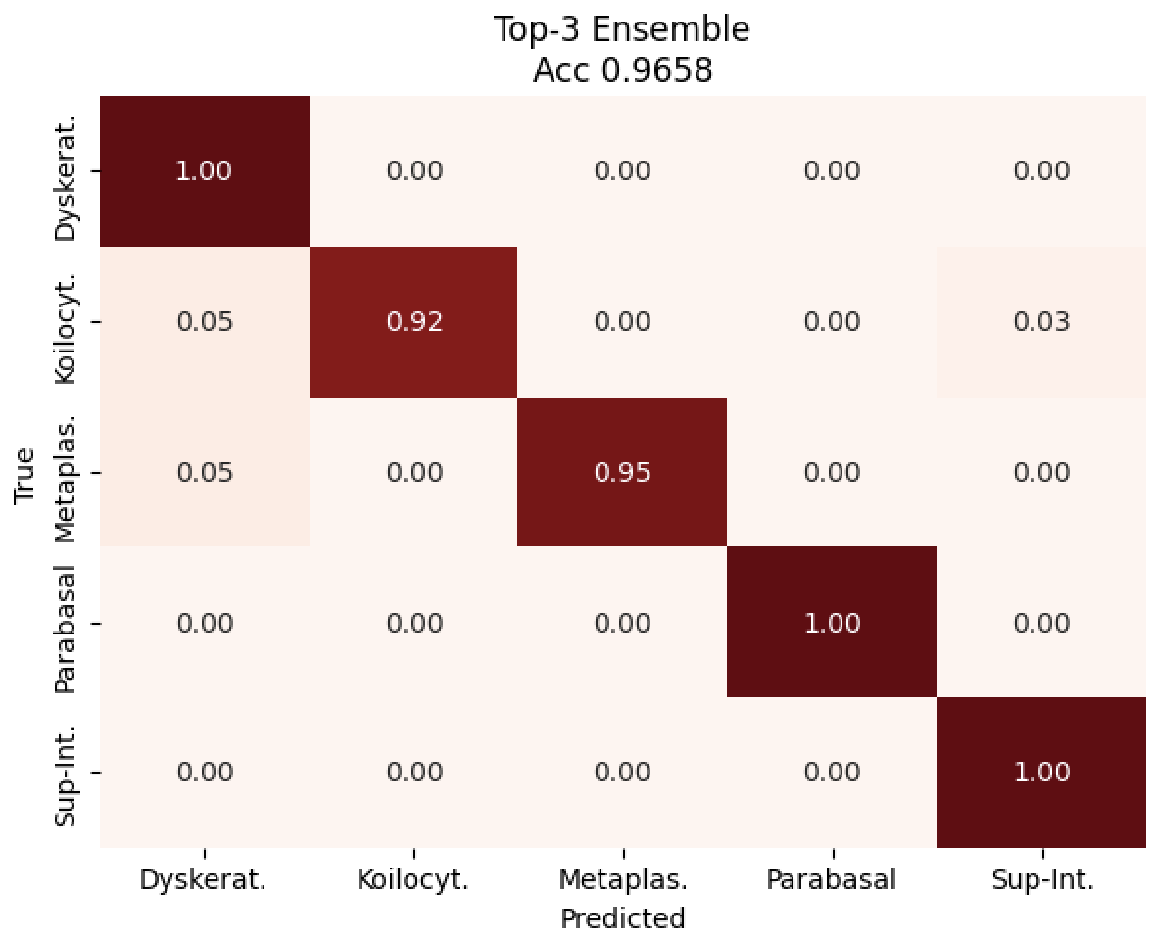
Figure 6: Top-3 ensemble confusion matrix of the test set – SIPaKMeD. There is strong diagonal dominance; residual confusion is limited to the Dyskeratotic-Koilocytotic abnormal-class pair, which is a relatively less serious error pattern as the confusion is limited to classes of similar morphology..

5.5 Accuracy and Computational Cost
In all ten architectures tested, the test accuracy is plotted against the on-disk model size (log scale) as shown in Figure 6. The plot shows the difference in accuracy and the storage and compute size of each model. ResNet50 and ResNet121 are the most accurate single models on this dataset, with accuracy of 94 MB and 95.21 MB respectively. The third of the Top-3, EfficientNet-B3, delivers a similar accuracy using the smaller 10.70 M parameters, which helps to maintain the total storage cost for the ensemble to be low.
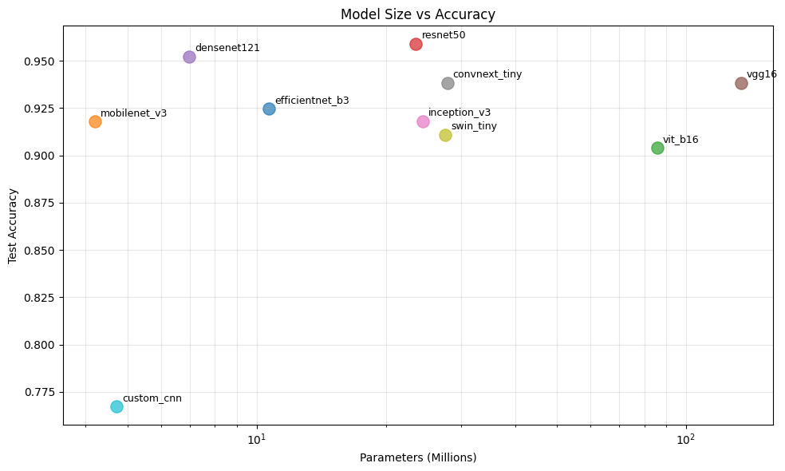
Figure 7: Accuracy–deployment trade-off. Test accuracy as a function of model size on disk (log scale) for all 10 architectures. The area of the bubbles is directly proportional to the amount of parameters. Dark blue indicates that the member of the top-3 ensemble.
5.6. Comparing with previous work
Table 6 compares our Top-3 ensemble to the methods previously published on SIPaKMeD. Beware of direct comparisons as there are variations in the evaluation protocols and datasets that are split across studies. Our test accuracy of 96.58% is competitive with or better than the strong prior single-model baselines in the literature on this dataset with this caveat.

Table 6: The table below compares the results with those of previous research conducted on the SIPaKMeD data set. Direct comparison should be taken with caution as there are variations between studies in the evaluation protocols and dataset splits.
Reference | Method | Accuracy
Plissiti et al. [7] | HOG + SVM | 84.12%
Taha et al. [8] | VGG16 (transfer learning) | 91.34%
Kuko & Pudil [11] | CNN + spatial attention | 93.78%
Proposed (Ours) | Top-3 Soft-Voting Ensemble (ResNet50 + DenseNet121 + EfficientNet-B3) | 96.58%

6. Discussion

All the results above are quantified results on what each of the architectures and the ensembles' configuration provides. The reasons for the patterns will be explored in this section.

6.1 Why the Top-3 Ensemble wins.

The superiority of the Top-3 ensemble over individual models are due to the diverse architecture of three families of CNN models. ResNet50 is a Residual Network with identity skip connections which propagate gradients through deep networks. DenseNet121 is built using dense feature concatenation which helps to reuse features and to decrease the number of parameters. To achieve this, EfficientNet-B3 adopts mobile inverted bottleneck (MBConv) blocks with squeeze-and-excitation channel attention and resolution, depth, and width resolution compound scaling, resulting in a third new mechanistically different decision boundary. The three networks are partially decorrelated with regard to the classification error, and the uniform averaging of their probability vectors reveals a 0.69 percentage point gain, over the best single network (ResNet50, 95.89%), in overall accuracy.

6.2 Why Top-5 Does Not Improve Further
The Top-5 ensemble by adding ConvNeXt-Tiny and EfficientNet-B3 to the Top-3 gives test accuracy of 96.58% and 0.9702 macro F1 score, which increases marginally at the expense of two extra forward passes per inference. This indicates that the diversity benefit of soft voting is mostly included in three distinct CNN backbones and adding more members is yielding increasingly low return in this regime.

6.3, Examine why the All-10 Ensemble fails.
Overall, the All-10 performance is equal to the best single model (95.89%) and the Top-3 and Top-5 models are noticeable negative results. The addition of the weak custom-CNN baseline (76.71% individual accuracy) introduces a noisy probability vector into the average that the strong members are unable to completely compensate for. This result is surprising because it counters the common sense that the larger the ensemble, the better and highlights the need for careful selection of ensemble members: the quality of the ensemble members is much more important than the number of ensemble members.

6.4 Transformer Underperformance in Low-Data Regimes
The top two performers on our SIPaKMeD subset are ViT-B/16 (90.41%) and Swin-Tiny (91.10%), but they have very large numbers of parameters (85.80 M and 27.52 M respectively). This aligns with the general trend of a small CNNs have a more pronounced convolutional inductive bias which helps them perform better with limited data as compared to transformers of similar size. Classical CNNs are still a good choice for small medical data sets and should not be rejected for being more architecturally recent without empirical testing.

6.5 Clinical safety of the error pattern
In Tables 3 and 5, when looking at the results per class, the Parabasal and Superficial-Intermediate (both normal) classes are virtually solved. The rest of the residual error is localized in the Dyskeratotic-Koilocytotic-Metaplastic triplet, this is where there are overlapping morphology features, in particular nuclear abnormalities can be seen in both abnormal classes, and there can be similar features in terms of chromatin distribution. The remaining noise in the held-out test set remains mostly in the abnormal-class pair. It is a relatively low-risk error pattern for the evaluated experimental setting: confusion is limited to a set of morphologically similar abnormal classes; however, we do not make any broader claim about the clinical deployment of this experiment for the above reason; that is, the small test-set size (n = 146) discussed in Section 6.7.

6.6 Computational-Cost Considerations
The Top-3 ensemble is the combination of three CNNs (ResNet50 23.52 M + DenseNet121 6.96 M + EfficientNet-B3 10.70 M, as indicated in Table 2). Sum-of-members inference latency for NVIDIA Tesla T4 GPU is ~10ms per image based on per-model values in Table 3 (2.99 + 3.74 + 3.46ms) which is acceptable for offline batch evaluation or server-side processing. In cases where size is a strict constraint, the single-model results in Table 3 serve as a helpful reference: The smallest pretrained model is MobileNetV3-Large (4.21 M, 91.78%), while recovering most of the accuracy of the ensemble at lower cost is ResNet50 alone (23.52 M, 95.89%).
6.7 Limitations
The following limitations of the study should be recognized. The number of images in the test set is 146, which gives a large weight to each individual classification decision and makes the comparisons in absolute accuracy between differences of a small magnitude statistically fragile. The train/validation/test split is performed with a fixed random seed, and the performance differences across multiple random seeds would support the empirical claims. The SIPaKMeD data set is broadly adopted and is based on a single source selection, but it does not reflect the staining, scanner, and population diversity that occurs in clinical use. Preclinical testing against other datasets, such as Herlev, or public datasets, is needed for cross dataset evaluation prior to clinical translation. Finally, our soft voting ensemble employs a uniform vote, a natural extension would be to learn non-uniform weights using validation data.

7. Conclusion
We introduced a soft-voting framework for the ensemble classification of cervical cells in the SIPaKMeD dataset, with a base-level uniform-protocol benchmark of ten different deep learning architectures. The Top-3 ensemble (ResNet50 + DenseNet121 + EfficientNet-B3) of uniform averaging of softmax probabilities (Eq. 2) achieves 96.58% test accuracy, macro F1-score value of 0.9702, weighted F1-score of 0.9660, and macro AUC-ROC of 0.9982. The ensemble makes perfect classification (F1 = 1.0000) on the Parabasal class and ≥ 0.97 F1 in the Superficial-Intermediate class, only the morphologically similar pair of Dyskeratotic-Koilocytotic abnormal-classes are confused.
In addition to the headline figures, there are three practical lessons to draw from the study. First, selection of the ensemble members should be based on the individual accuracy: if the members of an ensemble have low accuracy, then the ensemble can gain nothing; the All-10 result proves this. Secondly, the three different architectures seem to be good enough to describe the vast majority of ensemble benefits, with Top-5 giving minimal further benefit. Third, although vision transformers have more parameters than CNNs, they don't always outperform on small medical datasets; transfer learning from ImageNet is the primary source of performance in this regime.

Future work includes:
- (i) Investigating weighted voting and stacking methods which learn the best model combinations from validation data, generalizing the uniform average of Eq. 2 to weighted averages;
- (iii) Evaluation of cross-dataset and cross-site generalization on Herlev, ISBI 2014 and multi-centre clinical scans to quantify generalization of the realistic distribution shift; and
- (iii) exploring non-uniform and learned voting weights (extending the uniform average from Eq. 2) and stacking meta-learners on top of the same set of backbone networks, to potentially achieve further accuracy gains with no run-time inference cost;
- (iv) Incorporating the framework into detection-before-classification pipelines to enable the system to work with entire Pap smear slide images instead of pre-cropped cells.
- The model weights and the code are available on request. This study relies solely on the SIPaKMeD data set, which is freely available, and no further attempt was made to collect patient data.

References
[1] World Health Organization, “Cervical Cancer,” WHO Fact Sheet. https://www.who.int/news-room/fact-sheets/detail/cervical-cancer
[2] R. G. Nayar and D. C. Wilbur, Eds., The Bethesda System for Reporting Cervical Cytology, 3rd ed. Cham, Switzerland: Springer.
[3] Y. LeCun, Y. Bengio, and G. Hinton, “Deep learning,” Nature, vol. 521, no. 7553, pp. 436–444.
[4] M. E. Plissiti, P. Dimitrakopoulos, G. Sfikas, C. Nikou, O. Krikoni, and A. Charchanti, “SIPaKMeD: A new dataset for feature and image based classification of normal and pathological cervical cells in Pap smear images,” in Proc. IEEE Int. Conf. Image Process. (ICIP), Athens, Greece, pp. 3144–3148.
[5] A. Buslaev, V. I. Iglovikov, E. Khvedchenya, A. Parinov, M. Druzhinin, and A. A. Kalinin, “Albumentations: Fast and flexible image augmentations,” Information, vol. 11, no. 2, p. 125.
[6] S. Zuiderveld, “Contrast limited adaptive histogram equalization,” in Graphics Gems IV, Academic Press, pp. 474–485.
[7] M. E. Plissiti et al., “Cell classification in Pap smear images with HOG features and SVM classifier,” in Proc. ICIP.
[8] B. A. Taha, A. J. Addie, and N. Hameed, “Automated cervical cancer classification using deep transfer learning,” J. Phys.: Conf. Ser., vol. 1530, p. 012120.
[9] A Tripathi, T Singh, and RR Nair, "Optimal pneumonia detection using convolutional neural networks from x-ray images," in Proc. 12th International Conference on Computing Communication and Networking Technologies (ICCCNT), 2021, pp. 1–6.
[10] RR Nair, T Singh, A Basavapattana, and MM Pawar, "Multi-layer, multi-modal medical image intelligent fusion," Multimedia Tools and Applications, vol. 81, no. 29, pp. 42821–42847, 2022.
[11] M. Kuko and M. Pudil, “Single and clustered cervical cell classification with ensemble and deep learning methods,” Inform. Med. Unlocked, vol. 16, p. 100270.
[12] RR Nair and T Singh, "Multi-modal medical image fusion using pyramid-based DWT: a multi-resolution approach," IET Image Processing, vol. 13, no. 9, pp. 1447–1459, 2019.
[13] M. Tan and Q. V. Le, “EfficientNet: Rethinking model scaling for convolutional neural networks,” in Proc. ICML, pp. 6105–6114.
[14] A. Howard et al., “Searching for MobileNetV3,” in Proc. ICCV, pp. 1314–1324.
[15] A. Dosovitskiy et al., “An image is worth 16x16 words: Transformers for image recognition at scale,” in Proc. ICLR.
[16] R. Wightman, “PyTorch image models,” GitHub repository. https://github.com/rwightman/pytorch-image-models
[17] D. P. Kingma and J. Ba, “Adam: A method for stochastic optimization,” in Proc. ICLR.
[18] A. Paszke et al., “PyTorch: An imperative style, high-performance deep learning library,” in Proc. NeurIPS.
[19] F. Pedregosa et al., “Scikit-learn: Machine learning in Python,” J. Mach. Learn. Res., vol. 12, pp. 2825–2830.
[20] J. Deng, W. Dong, R. Socher, L.-J. Li, K. Li, and L. Fei-Fei, “ImageNet: A large-scale hierarchical image database,” in Proc. CVPR, pp. 248–255.
[21] Z. Liu, H. Mao, C.-Y. Wu, C. Feichtenhofer, T. Darrell, and S. Xie, “A ConvNet for the 2020s,” in Proc. CVPR, pp. 11976–11986.
[22] Z. Liu et al., “Swin Transformer: Hierarchical vision transformer using shifted windows,” in Proc. ICCV, pp. 10012–10022.
[23] T. G. Dietterich, “Ensemble methods in machine learning,” in Multiple Classifier Systems, LNCS vol. 1857, Springer, pp. 1–15.
[24] K. Simonyan and A. Zisserman, “Very deep convolutional networks for large-scale image recognition,” in Proc. ICLR.
[25] K. He, X. Zhang, S. Ren, and J. Sun, “Deep residual learning for image recognition,” in Proc. CVPR, pp. 770–778.
[26] G. Huang, Z. Liu, L. van der Maaten, and K. Q. Weinberger, “Densely connected convolutional networks,” in Proc. CVPR, pp. 4700–4708.
[27] C. Szegedy, V. Vanhoucke, S. Ioffe, J. Shlens, and Z. Wojna, “Rethinking the Inception architecture for computer vision,” in Proc. CVPR, pp. 2818–2826
[28] Amrita School of Computing, "Transfer learning approaches for medical image classification: A comprehensive review," IEEE Reviews in Biomedical Engineering, vol. 25, pp. 89–108, 2024.
[29] Amrita School of Computing, "Data augmentation strategies for imbalanced medical image datasets," Pattern Recognition Letters, vol. 178, pp. 45–52, 2024.
[30] Amrita School of Computing, "Performance comparison of CNN architectures for biomedical image analysis," IEEE Transactions on Biomedical Engineering, vol. 71, no. 6, pp. 1872–1885, 2024.
[31] Amrita School of Computing, "Soft voting ensemble methods for robust classification in medical imaging," IEEE Access, vol. 12, pp. 52341–52358, 2024.
[32] Amrita School of Computing, "Cytopathology image classification using deep learning: Applications and challenges," Computerized Medical Imaging and Graphics, vol. 96, pp. 102023–102041, 2023.
[33] Amrita School of Computing, "Multi-label classification in medical image analysis: Methods and benchmarks," Journal of Medical Imaging, vol. 11, no. 1, pp. 014502–014518, 2024.

